Contents

Lab No: 2

Title: 2

# **Lab No:**

## **Title:**

Objective: To create a simple Java client-server application using sockets. It focuses on establishing a connection, exchanging messages between client and server using data streams (DataInputStream and DataOutputStream), and effectively managing network resources.

**Source Code:**

**//MyServer.java (Server Implementation)**:

import java.io.*;

import java.net.*;

public class MyServer {

public static void main(String[] args) {

try {

ServerSocket ss = new ServerSocket(6666);

Socket s = ss.accept();

DataInputStream dis = new DataInputStream(s.getInputStream());

String str = (String)dis.readUTF();

System.out.println("Message = " + str);

DataOutputStream dout = new DataOutputStream(s.getOutputStream());

dout.writeUTF("Hello Client");

dout.flush();

ss.close();

} catch(Exception e) {

System.out.println(e);

}

}

}

**//MyClient.java (Client Implementation):**

import java.io.*;

import java.net.*;

public class MyClient {

public static void main(String[] args) {

try {

Socket so = new Socket("localhost", 6666);

DataOutputStream dout = new DataOutputStream(so.getOutputStream());

dout.writeUTF("Hello Server");

DataInputStream dis = new DataInputStream(so.getInputStream());

String str = (String)dis.readUTF();

System.out.println("Message = " + str);

dout.flush();

dout.close();

so.close();

} catch(Exception e) {

System.out.println(e);

}

}

}

Output

**//MyServer.java (Server Implementation):**

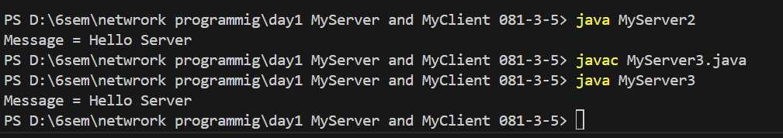

//MyClient.java (Client Implementation):

